2. CSS Layout (5 Marks):
a) Use Flexbox or CSS Grid to create a layout for the webpage.
b) Organise content into at least three sections (e.g., header, content area, and footer) using appropriate containers.
c) Apply styling to the containers using Flexbox or Grid properties to create a visually distinct layout.
d) Ensure that the layout is well-structured and easy to navigate.

a) Use Flexbox or CSS Grid to create a layout for the webpage.
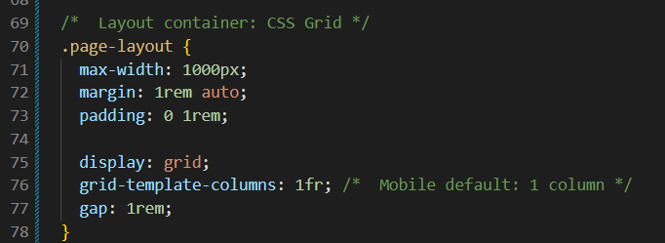

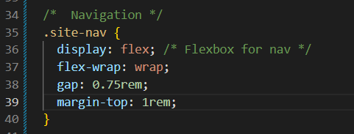
b) Organise content into at least three sections (e.g., header, content area, and footer) using appropriate containers.
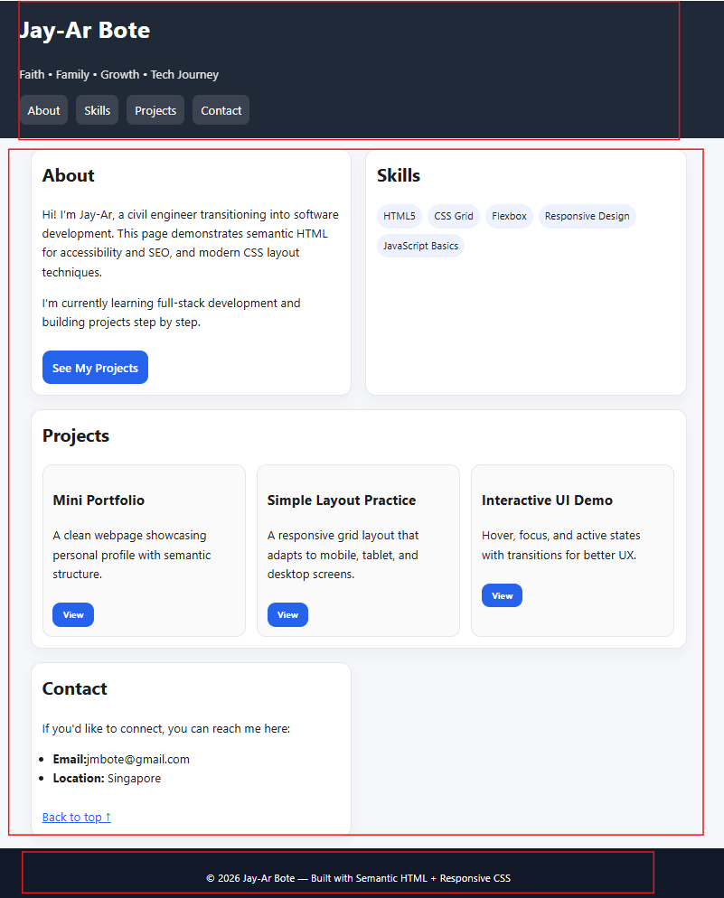
c) Apply styling to the containers using Flexbox or Grid properties to create a visually distinct layout.
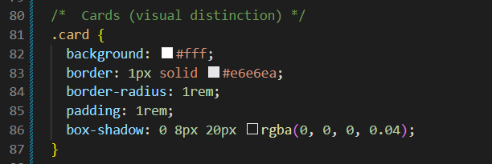
d) Ensure that the layout is well-structured and easy to navigate.

